**Topics: Descriptive Statistics and Probability**

1. Look at the data given below. Plot the data, find the outliers and find out $μ, σ, σ^{2}$

|  |  |
| --- | --- |
| **Name of company** | **Measure X** |
| Allied Signal | 24.23% |
| Bankers Trust | 25.53% |
| General Mills | 25.41% |
| ITT Industries | 24.14% |
| JPMorgan & Co. | 29.62% |
| Lehman Brothers | 28.25% |
| Marriott | 25.81% |
| MCI | 24.39% |
| Merrill Lynch | 40.26% |
| Microsoft | 32.95% |
| Morgan Stanley | 91.36% |
| Sun Microsystems | 25.99% |
| Travelers | 39.42% |
| US Airways | 26.71% |
| Warner-Lambert | 35.00% |

**Solution –**

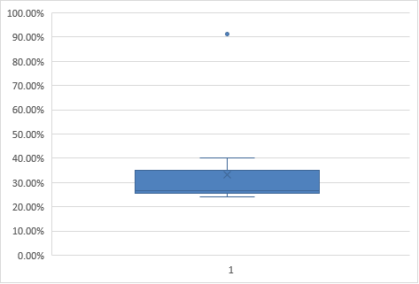





Answer the following three questions based on the box-plot above.

1. What is inter-quartile range of this dataset? (Please approximate the numbers) In one line, explain what this value implies.

**Answer** - **IQR = Q3 – Q1 = 19-0 = 19**

**IQR of 19 implies that there are 19 values which resides in the middle of the data while ignoring the outlier.**

1. What can we say about the skewness of this dataset?

**Answer** – **The data is Positively skewness.**

1. If it was found that the data point with the value 25 is actually 2.5, how would the new box-plot be affected?

**Answer – The data will be totally changed. There will be no outlier in the data and also there will be significant change in the mean value. Lastly also it seems like the data will be normally distributed.**



Answer the following three questions based on the histogram above.

1. Where would the mode of this dataset lie? –

**Answer -** **Mode is the value which occurs most of the time. In this case it seems value 20 occurs quite frequently.**

1. Comment on the skewness of the dataset. –

**Answer - Positively skewed as Median < Mean.**

1. Suppose that the above histogram and the box-plot in question 2 are plotted for the same dataset. Explain how these graphs complement each other in providing information about any dataset.

**Answer –**

**Histograms and box plots are very similar in that they both help to visualize and describe numeric data.**

**Although histograms are better in determining the underlying distribution of the data like it show if the data is normally distributed or not and also the Skewness and kurtosis of the data.**

**On the other hand, box plots allow you to compare multiple data sets better than histograms as they are less detailed and take up less space. A box plot will graphically represent the five most important descriptive values for a data set. These values include the minimum value, the first quartile, the median, the third quartile, and the maximum value.**

1. AT&T was running commercials in 1990 aimed at luring back customers who had switched to one of the other long-distance phone service providers. One such commercial shows a businessman trying to reach Phoenix and mistakenly getting Fiji, where a half-naked native on a beach responds incomprehensibly in Polynesian. When asked about this advertisement, AT&T admitted that the portrayed incident did not actually take place but added that this was an enactment of something that “could happen.” Suppose that one in 200 long-distance telephone calls is misdirected. What is the probability that at least one in five attempted telephone calls reaches the wrong number? (Assume independence of attempts.)

**Solution –**

**Probability of call misdirecting, p = 1/200**

**Probability of call not Misdirecting, q= 1 - 1/200 = 199/200**

**Number of Calls = 5**

**n = 5**

**p = 1/200**

**q = 199/200**

**at least one in five attempted telephone calls reaches the wrong number**

**= 1  -  none of the call reaches the wrong number**

**= 1  -  (199/200)⁵**

**= 0.02475**

1. Returns on a certain business venture, to the nearest $1,000, are known to follow the following probability distribution

|  |  |
| --- | --- |
| x | P(x) |
| -2,000 | 0.1 |
| -1,000 | 0.1 |
| 0 | 0.2 |
| 1000 | 0.2 |
| 2000 | 0.3 |
| 3000 | 0.1 |

1. What is the most likely monetary outcome of the business venture?

**Answer - As the maximum probability of earning is 0.3. the most likely outcome would be $2,000,000.**

1. Is the venture likely to be successful? Explain

**Answer** –



**Venture is likely to be successful as the expected value is 800. Also there is only 0.2 probability that the venture will make loss.**

1. What is the long-term average earning of business ventures of this kind? Explain

**Answer - Expected value = Long-term average = 800.**

1. What is the good measure of the risk involved in a venture of this kind? Compute this measure

**Answer – Generally good measure of risk are Range, Variance and Standard deviation.**

